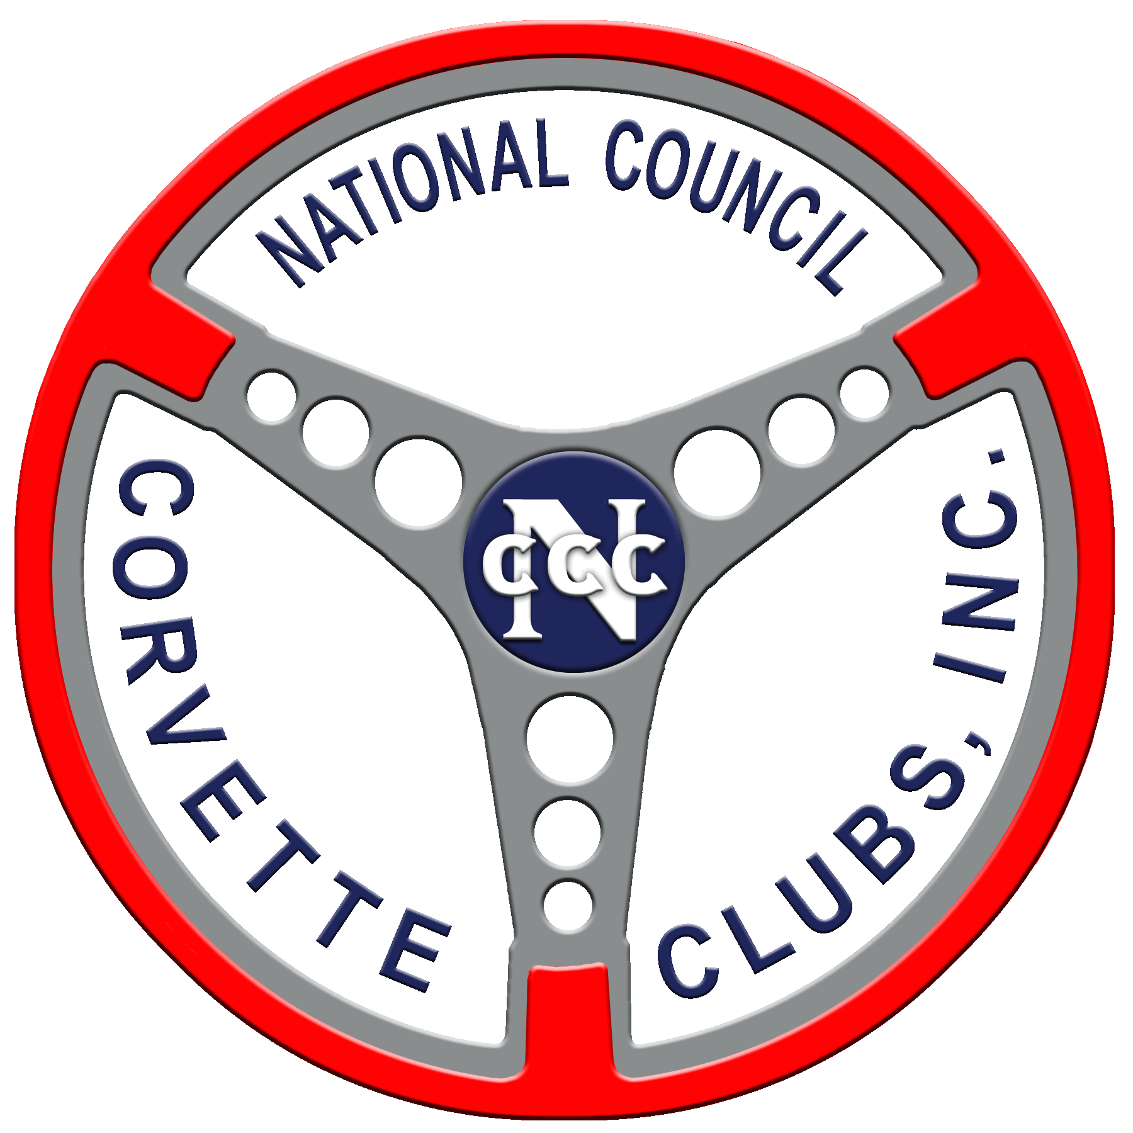
NCCC Family Helping Family Volunteer Form

Name:
Phone #’s Home: Cell:
E-mail Address:
City: State:
Corvette Club’s Name:
Region:
Below, specify what would you like to Volunteer for; i.e. Mechanical Experts, have a trailer, knowledge of a good mechanic, Spare Bed, or if you would like to have conversation and a cup of coffee.
I would like to Volunteer for: (check all that apply by putting an “X” in the box at the beginning of the line)

Mechanical expertise
Provide a car trailer to haul your ride
Knowledge of a good mechanic or dealership to take your ride to
Have a spare bed for you to spend the night
You are welcome to stop in for refreshments and conversation
Other:

We would like to Thank You in Advance for your participation in this Family Helping Family Program.
We ask that the form or information on the form be sent to our Director of Public Relations. Douglas McMahan can be reached at e-mail address PublicRelations@corvettesnccc.org or cell phone number 972-998-1589.

